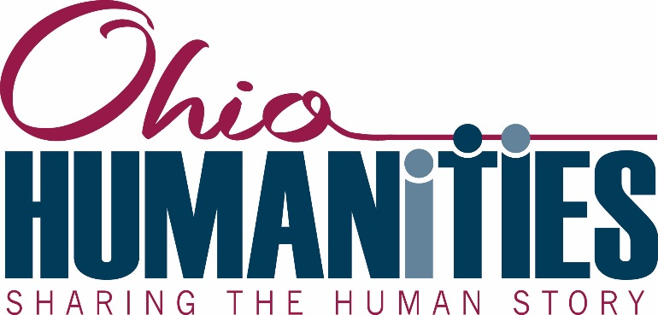

Project Director’s Guide for Ohio Humanities Funded Projects

Congratulations on your grant award!

Included in this package are:
- An official notification letter
- Two copies of a grant agreement
Please return one signed copy of the grant agreement to Ohio Humanities and keep the other for your files
- The logo is available by contacting the Communications Director Missy Ricksecker mricksecker@ohiohumanities.org .
- Contact information for your legislators and for Ohio Humanities Board Members
- Grant reporting will take the form of paper and online submissions. Ohio Humanities will send two emails to the project director over the course of the grant. The first email is sent after the grant has been awarded and has a link to the Event Data Form. The second email is sent when the project approaches completion and has a link to the Final Report Form.
- The necessary paper forms are included with the packet and are available on the Ohio Humanities website.

We require the use of these forms to properly document projects and comply with government regulations.

Budget Management
Now that the grant is awarded, you must establish a method of maintaining records and financial accounts consistent with accepted accounting principles. You should keep copies of your records for three years after submitting the final report.

Included among your records must be auditable proof of cost-sharing for the project. This includes any funds or resources of definable value contributed to the project other than the Ohio Humanities grant. Any revenue received as part of the project must be reported as part of the cost share. Other federal funds cannot serve as cash cost-share.

Disbursement of Grant Funds and Confirmation of Project Events
Grant reporting will take the form of paper and online submissions. Ohio Humanities will send two emails to the project director on file over the course of the grant. Additional reminder emails may be received if tasks have not been completed in a timely fashion.

The first email is sent after the grant has been awarded and has a link to the Event Data Form. The second email is sent when the project approaches completion and it has a link to the Final Report Form. Please contact Ohio Humanities at once if the contact information, especially the email address, of the project director changes.

When the signed grant agreement has been returned to Ohio Humanities, you may request up to 75% of the funds awarded. To do this, complete and return the Disbursement of Grant Funds Request included in this packet. You may choose to wait until the conclusion of the project and then request full reimbursement, if that is more convenient. Ohio Humanities withholds 25% of each grant until a final report has been submitted to and approved by Ohio Humanities.

To comply with Federal requirements, Ohio Humanities must have a copy of your IRS Letter Designating non-profit status [i.e. 501 (c) 3] if your organization has such status on file.

At the time of disbursement, please complete the Event Data Form online. You will receive an email with a link to this form. Grant funds will not be disbursed until project events are submitted. You may add additional events later using the link in the email. If you need to make changes to events along the way, please contact a program officer. The online Final Report Form will offer you the opportunity to provide updated and accurate information for all events.

The Event Data Form must be completed at least two weeks prior to your first public event. By completing this form, Ohio Humanities will have on file the following information about each separate event that is a part of your project:
1. The date and time of specific events
2. The street address, city and zip code where the event will occur (no PO Boxes, please)
3. Identity of all participating humanities scholars
4. The name of a contact person for more information
5. The contact person’s telephone number and/or e-mail address.
6. Names, zip codes, and email addresses of attendees for all public events.

This information will be used to help Ohio Humanities publicize your event on its calendar, social media, and other outlets. Providing timely, accurate, and updated information is essential.

Acknowledgement of Ohio Humanities Support
Ohio Humanities wants to inform the public of its role in supporting worthy programs. Ohio Humanities requires an acknowledgment of its support in press releases, flyers, posters, printed brochures, exhibits, videos, electronic publications, or other materials.
- Graphics: Minimum logo size for print and online use is 7/8 x 1 3/4". Logo may be used in either full color or black and white as use dictates. Logo may not be used in other colors, distorted nor as a background or foreground with other graphics. For complete details of logo use, contact Communications Director, Missy Ricksecker, mricksecker@ohiohumanities.org .
- Public Event: At any public event, such as a lecture or panel discussion, you must verbally acknowledge Ohio Humanities support at the beginning of the program.
- Text: Text should include the following statements: “This program is made possible, in part, by Ohio Humanities, a state affiliate of the National Endowment for the Humanities. Any views, findings, conclusions or recommendations expressed in this (publication) (program) (exhibition) (website) do not necessarily represent those of the National Endowment for the Humanities.”

Advocacy
Ohio Humanities has been given the trust of administering public funds and must demonstrate to lawmakers the effective use of those monies. Therefore, please write to each of your legislators to inform them of your project and of Ohio Humanities support. We encourage you to contact your representatives’ national and regional offices and invite them to your events.

The mission of Ohio Humanities is to help individuals and communities explore, share, and be inspired by the human experience. To ensure that we are reaching Ohioans in every corner of our state we need to know who is attending our sponsored events and where they are coming from. This information will ONLY be used by Ohio Humanities. It will not be sold or shared with other organizations.

Participation Record: Please collect the names, zip codes, and email addresses event attendees. This includes participants as well as audience members. The information you collect should be submitted electronically rburns@ohiohumanities.org within 10 business days after each public event. You can find a sample at the Funded Projects Resources page.

If you have any questions please contact Roger Burns, Development Director at (rburns@ohiohumanities.org).

Publicity
Because Ohio Humanities’ mission is to provide educational humanities programs to all Ohioans, the Council places a high priority on effective publicity for the projects it funds. Ohio Humanities relies on you—the project director—to implement the publicity plan described in your proposal in a timely and thorough manner.
- Press Releases: Publicity efforts should include sending press releases to local newspapers and broadcasters. Please mention Ohio Humanities support in all press releases.
- Communications Director: Ohio Humanities is able to help you promote your project through our print and electronic publications. Please provide digital copies of brochures, photos, and other visual materials to the Communications Director mricksecker@ohiohumanities.org well ahead of your public activities.
- Social media: We want to make connections with you on those platforms (we are @ohiohumanities on twitter and facebook.com/ohiohumanities).
- Ohio Humanities Board Members: Please send an invitation to public events and copies of publicity materials to Ohio Humanities board members. See award packet for contact information.
- Internet content: If you create any web content for your funded project, we ask that you send a link to mricksecker@ohiohumanities.org when the content is published.

Questions
If you have any questions about Ohio Humanities procedures or if our staff can help in any way to ensure your project’s success, please do not hesitate to contact us. Our program officers will be glad to assist you.

